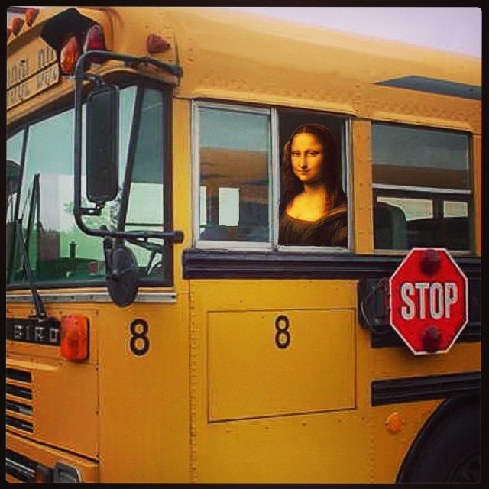
Welcome to 5/6 Miscoe Art with Mrs. Gentili!

I am excited to be back at school to welcome your child into the art room. I was thrilled to spend some of my summer in the Project Zero Classroom program at the Harvard Graduate School of Education studying big ideas by prominent figures in education that I admire. I am taking this experience into the classroom with a renewed commitment to project based learning with a generous amount of technology integration. Our focus will be on the process of art making and for this, your child will keep a sketchbook/artist journal. Our first project will be to make the sketchbooks; please don’t buy one.

Assessment and grading will be based on the 8 Studio Habits of Mind as follows:
1. Develop Craft: Learning to use tools, materials, artistic conventions; and learning to care for tools, materials, and space.
2. Engage & Persist: Learning to embrace problems of relevance within the art world and/or of personal importance, to develop focus conducive to working and persevering at tasks.
3. Envision: Learning to picture mentally what cannot be directly observed, and imagine possible next steps in making a piece.
4. Express: Learning to create works that convey an idea, a feeling, or a personal meaning.
5. Observe: Learning to attend to visual contexts more closely than ordinary “looking” requires, and thereby to see things that otherwise might not be seen.
6. Reflect: Learning to think and talk with others about an aspect of one’s work or working process, and learning to judge one’s own work and working process and the work of others.
7. Stretch & Explore: Learning to reach beyond one’s capacities, to explore playfully without a preconceived plan, and to embrace the opportunity to learn from mistakes.
8. Understand (Arts) Community: Learning to interact as an artist with other artists (i.e., in classrooms, in local arts organizations, and across the art field) and within the broader society.
- Studio Habits of Mind from Studio Thinking: The Real Benefits of Visual Arts Education, Hetland, Winner, et al, Teachers College Press, 2007.

Your child is invited to join Art Club on Wednesdays from 2:45 – 3:45, which runs independent of Enrichment classes. See me for a registration form for Art Club. On Tuesdays I will be teaching Clay classes through Enrichment. Flat Clay! What Did You Say? will be offered this session.

I will send an email when the iPads are rolled out with instructions on apps and websites NOT to block, such as our online gallery at Artsonia.com. Please identify me (agentili@mursd.org) as “not junk/ not spam” in your email settings. To stay up-to-date with what is going on in the 5/6 Art room, follow my Facebook page at www.facebook.com/MonaLisaLiveshere and my Instagram account at @MonaLisaLivesHere.

Have a wonderful school year!

